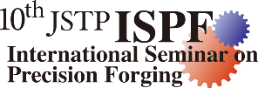
JSTP International Seminar on Precision Forging

(10th ISPF)
Organized by the Forging Committee of Japan Society for Technology of Plasticity

APPLICATION FORM for GENERAL PARTICIPANT
(Deadline: January 31st, 2027)

Applicant
Name:
Last (Family): First: Other names:
Title (for mail): Mr. Ms. Dr. Position: Nationality: Age:
E-mail:
Postal address:

Outline of your work in relation to precision forging

Signature: Date:

Return to
Dr. Y. Yoshikawa (Meijo University, Japan)
The secretary of the organizing committee of the 10th ISPF
E-mail: secretary@jstp-ispf.com

