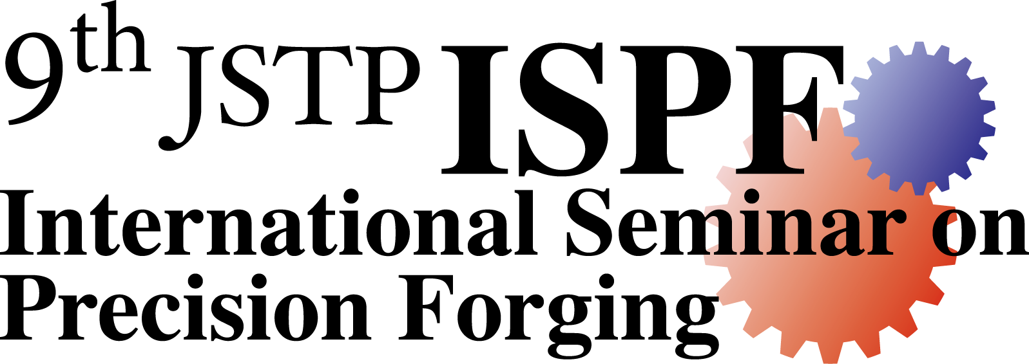
JSTP International Seminar on Precision Forging
(9th ISPF)
Organized by Japan Society for Technology of Plasticity (JSTP)

Outline:
The "JSTP International Prize for R&D in Precision Forging" was established in 1996 to promote research and development in precision forging and other net shape forming methods with a fund donated by Nichidai Corporation. The 10th prize is to be given to Prof. P. Groche and Prof. J. Yanagimoto at the 14th ICTP (Mandelieu-La Napoule, France) in September 2023. As an associated event of the prize, an "International Seminar on Precision Forging" (ISPF) will be held in Kyoto, Japan on 11th–14th March, 2024.

Past winners of JSTP International Prize: 1st (1996) Prof. H. Kudo and Prof. T. Altan
2nd (1999) Prof. K. Lange and Dr. H. Pugh
3rd (2002) Prof. K. Kondo and Prof. M. Geiger
4th (2005) Prof. N. Bay and Prof. K. Osakada
5th (2008) Prof. T.A. Dean and Prof. R. Kopp
6th (2011) Prof. J.-L. Chenot and Prof. T. Nakamura
7th (2014) Prof. A.E. Tekkaya and Prof. K. Mori
8th (2017) Prof. C.-G. Kang and Prof. T. Ishikawa
9th (2021) Prof. J.M. Allwood and Prof. P.A.F. Martins
10th (2023) Prof. P. Groche and Prof. J. Yanagimoto

Seminar:
The seminar consists of keynote lectures by the prize winners and guest speakers, and oral/poster presentations by invited young researchers/engineers in order to lead the new technology in precision forging. Factory visit (Nichidai Corporation and some hot/cold forging factories) will be arranged.

Travel grant for young researchers/engineers:
About 30 young researchers/engineers under 35 years old will be invited to the seminar with the travel grants. They are widely invited and welcomed from various research fields in "plastic working (forging, extrusion, rolling, sheet forming and so on)". Those who are invited have to present their research work by oral/poster presentation at the seminar. They have to submit extended abstract of their research work for the proceedings of the seminar.
The lowest international airfare from the nearest airport of the working place to the seminar venue and the hotel charge during the seminar will be granted. For the application to the grant, please use the attached application form. The result whether the applicant is invited with travel grant or no, and the amount of the grant will be notified until December 2023.

General participants:
About 50 experienced researchers/engineers (regardless their ages) are welcome to join the seminar as the general participants. They are expected to give some comments and discussions at the seminar. The seminar will be a good opportunity to acquire the up-to-date information on precision forging technology. For general participants, the accommodations and meals will be arranged, but the expenses for the travel, hotel fees and meals are not granted.

Schedule:
November 3rd, 2023: Deadline for application to the travel grant.
December 8th, 2023: Notification of the acceptance of the travel grant.
January 19th, 2024: Deadline for extended abstract for proceedings.
March 11th and 12th, 2024: Lectures and presentations in Kyoto Terrsa (Kyoto).
March 13th and 14th, 2024: Visit to industries (Hot and cold forging plants, and Nichidai Corporation etc.).

Lecturers:
The 10th prize winners and some leading researchers will give lectures. The ninth prize winners also will give lectures because the seminar was not held after the award ceremony of the ninth prize in 2021. The latest lectures member list will be uploaded on the ISPF homepage.

Further information of the 9th ISPF (Mailing address of application form):
Dr. Y. Yoshikawa
The secretary of the organizing committee of the 9th ISPF
Meijo University
1-501 Shiogamaguchi, Tenpaku-ku, Nagoya, Aichi 468-8502, Japan
E-mail: secretary@jstp-ispf.com

Updating of information by Internet (under construction, it will appear in November):

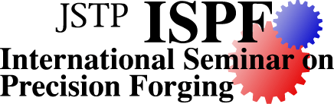
ISPF homepage: http://www.jstp-ispf.com/

Past ISPF:
JSTP International Seminar on Precision Forging (ISPF) was held in Osaka (1997, 2000), Nagoya (2004, 2015, 2018), Nara (2006) and Kyoto (2009, 2013), respectively. In the seminar, about 10 active researchers/engineers reviewed the recent development of precision forging technology, and the invited young researchers/engineers introduced their own activities. There were about 100 participants at each seminar. The past 1st-8th ISPF are listed in the following web page.

ISPF homepage: http://www.jstp-ispf.com/

Nichidai Corporation:
Nichidai Corporation is one of famous die-makers in the world, and designs, manufactures and sells many kinds of precision dies and precision forged products. Nichidai Co. Ltd. has contributed to JSTP for establishing the International Prize for R&D in Precision Forging and the ISPF. The president of Nichidai Co. Ltd. would like to stimulate not only the R&D in precision forging technology but also the international exchange and understanding among young researchers/engineers over the world. The further information about Nichidai Co. Ltd. can be seen in the following web page.

Nichidai Corporation homepage: http://www.nichidai.jp/english/

Organizing committee:
Prof. K. Kitamura (Chair), Nagoya Institute of Technology, Japan
Prof. M. Otsu (Vice Chair), University of Fukui, Japan
Dr. Y. Yoshikawa (Secretary-General), Meijo University, Japan
Dr. M. Terano (Treasurer), Okayama University of Science, Japan
Prof. Y. Yoshida, Gifu University, Japan
Dr. R. Matsumoto, Osaka University, Japan
Dr. E. Murai, Nichidai Corporation, Japan
Dr. K. Asai, National Institute of Technology, Toyota College, Japan
Prof. T. Ishikawa (Adviser), Chubu University, Japan

