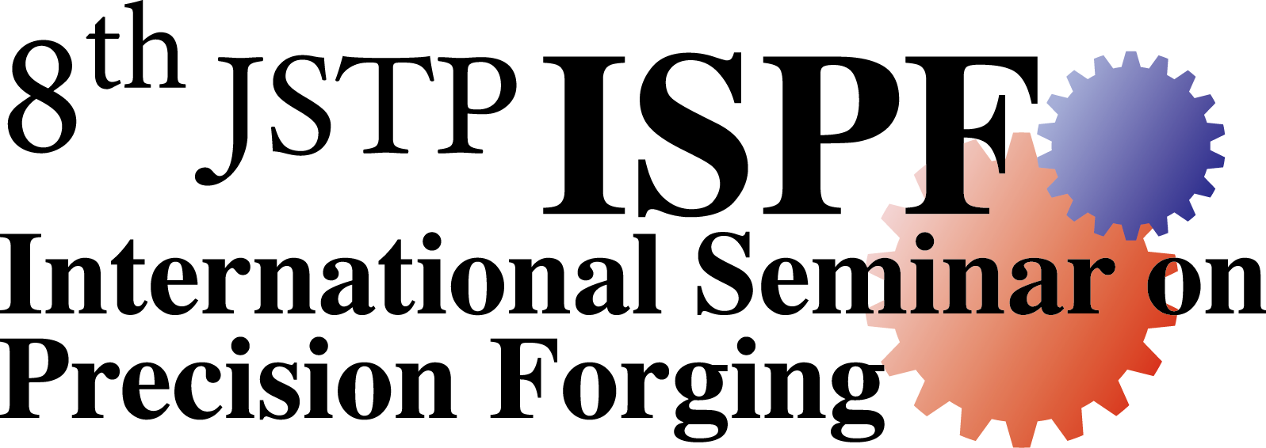
JSTP International Seminar on Precision Forging (8th ISPF)
5-8 March 2018
Nagoya Institute of Technology, Nagoya, Japan
Organized by the forging committee of Japan Society for Technology of Plasticity

APPLICATION FORM for TRAVEL GRANT

Applicant
Name:
Last (Family): First: Other names:
Title (for mail): Mr. Ms. Dr. Position: Nationality: Age:
Address:

Fax (add country code):
E-mail:
Curriculum vitae (One sheet of A4): to be attached.

Outline of your work in relation to precision forging

□ I want to give an oral presentation at the seminar.
Title of your topic:
□ I want to give a poster presentation at the seminar.
Title of your topic:
□ Abstract of oral/poster presentation at the seminar (about 300 words; One sheet of A4): to be attached.
□ List of publications (One sheet of A4): to be attached.
□ One or two typical your papers/reports in your study/work: to be attached (not to be returned in any case).
□ Letter of recommendation by your supervisor: to be attached (not to be returned in any case).

Air fare to Nagoya (Chubu Centrair International Airport) from your nearest international airport

Airport:
Lowest fare you can use: (Your currency) = US$

Signature: Date:

Return to
Prof. K. Hayakawa
The secretary of the organizing committee of the 8th ISPF
Shizuoka University
3-5-1 Johoku, Naka-ku, Hamamatsu 432-8561, Japan
FAX: +81-53-478-1043 E-mail: secretary@jstp-ispf.com
Deadline: 24 November 2017

